In this chapter, we will discuss the different Database Methods in ArangoDB.

To start with, let us get the properties of the Database −

* Name
* ID
* Path

First, we invoke the Arangosh. Once, Arangosh is invoked, we will list the databases we created so far −

We will use the following line of code to invoke Arangosh −

127.0.0.1:8529@_system> db._databases()

Output

[

"_system",

"song_collection"

]

We see two databases, one **_system** created by default, and the second **song_collection** that we have created.

Let us now shift to song_collection database with the following line of code −

127.0.0.1:8529@_system> db._useDatabase("song_collection")

Output

true

127.0.0.1:8529@song_collection>

We will explore the properties of our song_collection database.

To find the name

We will use the following line of code to find the name.

127.0.0.1:8529@song_collection> db._name()

Output

song_collection

To find the id −

We will use the following line of code to find the id.

song_collection

Output

4838

To find the path −

We will use the following line of code to find the path.

127.0.0.1:8529@song_collection> db._path()

Output

/var/lib/arangodb3/databases/database-4838

Let us now check if we are in the system database or not by using the following line of code −

127.0.0.1:8529@song_collection&t; db._isSystem()

Output

false

It means we are not in the system database (as we have created and shifted to the song_collection). The following screenshot will help you understand this.

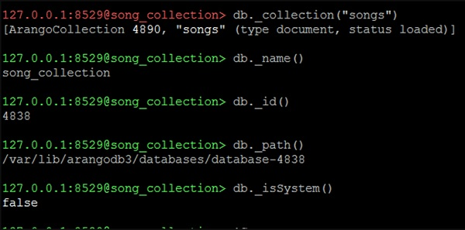

To get a particular collection, say songs −

We will use the following line of code the get a particular collection.

127.0.0.1:8529@song_collection> db._collection("songs")

Output

[ArangoCollection 4890, "songs" (type document, status loaded)]

The line of code returns a single collection.

Let us move to the essentials of the database operations with our subsequent chapters.